Bangladesh Medical Association (BMA)
List of Life Member-47
40. BMA Munshiganj Branch

Sl No | Voter No | Voter Details
1 | Voter No  LM-4000001  No Image | DR. MD. ABDUL QUARDER  F/Name: Munshigonj  M/Name:  BM & DC Reg. No:  NID:  Cell:  Address: E X P l R E D  Blood Group:  E X P I R E D
2 | Voter No  LM-4000002  No Image | DR. ANIMA RANI DAS  F/Name:  M/Name:  BM & DC Reg. No:  NID:  Cell:  Address: Thana Health Complex, Sreenagor  Munshigonj  Blood Group:
3 | Voter No  LM-4000003  No Image | DR. MD. AYUB ALI  F/Name: Md. Sumir Uddin  M/Name:  BM & DC Reg. No:  NID:  Cell:  Address: Medical Officer T.H.C, Tongi Bari  Munshigonj  Blood Group:
4 | Voter No  LM-4000004  No Image | DR. MD. JAHIRUL HOQUE  F/Name:  M/Name:  BM & DC Reg. No:  NID:  Cell:  Address: Transfered to BMA Comilla Branch  Blood Group:  TRANSFERED to BMA Dhaka City  LM-1405543
5 | Voter No  LM-4000005  No Image | DR. MD. ABDUR ROUF  F/Name:  M/Name:  BM & DC Reg. No:  NID:  Cell:  Address: Transfered T0 Dhaka City. LM-2841.  Blood Group:  TRANSFERED to BMA Dhaka City  LM-1405543
6 | Voter No  LM-4000006  No Image | DR. M. AKHTER HOSSAIN  F/Name: Mohammed Hossain  M/Name:  BM & DC Reg. No:  NID:  Cell:  Address: Dreams' Courlgaon  Munshigonj  Blood Group:
7 | Voter No  LM-4000007  No Image | DR. SHIRIN SULTANA  F/Name: Khalilur Rahman Miazi  M/Name:  BM & DC Reg. No:  NID:  Cell:  Address: Mathpara, P.O + P.S.- Munshigonj  Munshigonj  Blood Group:
8 | Voter No  LM-4000008  No Image | DR. MD. ABDUL BATEN  F/Name: Alhaz Ahmed Ali  M/Name:  BM & DC Reg. No:  NID:  Cell:  Address: B.C.S (Health & P.P) 1982 Upazila Health & P.P Officer Sirazdikhan, Munshigonj.  Blood Group:
9 | Voter No  LM-4000009  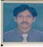 | DR. MD. MIZANUR RAHMAN  F/Name: Late Md. Moazzem Hossen  M/Name:  BM & DC Reg. No:  NID:  Cell:  Address: Mithu Oushad Ghar  Ramgopalpur, Rakabibazar  Munshigonj.  Blood Group:
10 | Voter No  LM-4000010  No Image | DR. MD. MIZANUR RAHMAN  F/Name: Md. Earshad Ali  M/Name:  BM & DC Reg. No:  NID:  Cell:  Address: R M O, General Hospital Munshigonj.  Blood Group:
11 | Voter No  LM-4000011  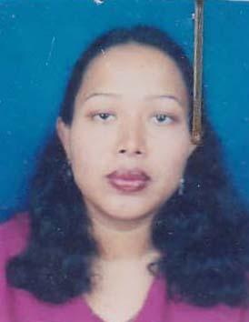 | DR. GAUSIA BEGUM  F/Name: Late. A.k.m. Abdur Rahim  M/Name: Mrs. Rahima Begum  BM & DC Reg. No: 45572  NID: 5925611101139  Cell: 01711784816  Address: Vill: Uttar Court Gaon, Malpara, 75/2 Malpara, Dist: Munshigonj, Post: Munshigonj.  Blood Group: B+
12 | Voter No  LM-4000012  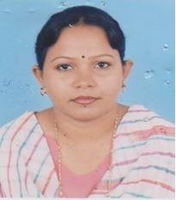 | DR. NASIMA AKTER  F/Name: Mr. Kutub Uddin Ahmed  M/Name: Mrs. Sufia Ahmed  BM & DC Reg. No: 34022  NID: 5925614104272  Cell: 01711287726  Address: Doctor\'s Care & Pathology Super Market, Munshiganj.  Blood Group: B+
13 | Voter No  LM-4000013.  No Image | DR. HASAN RAHMAN  F/Name: Abdur Rahman  M/Name:  BM & DC Reg. No:  NID:  Cell:  Address: 75/2, Uttar Coartgaon (Malpara)  Munshigonj  Blood Group:
14 | Voter No  LM-4000014  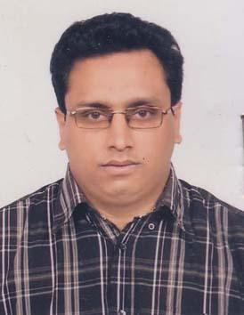 | DR. MD. YOUSUF UR RAHMAN  F/Name: Khabir Uddin Ahmed  M/Name: Rabe Khatun  BM & DC Reg. No: 39974  NID:  Cell: 01716282452  Address: 192/1, Shantibag, Dhaka.  Blood Group: B+
15 | Voter No  LM-4000015  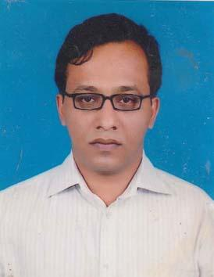 | dR. AMIRUZZAMAN  F/Name: Md. Abdul Bepari  M/Name: Mrs. Hasina Pervin  BM & DC Reg. No: 36136  NID: 592561104594  Cell: 01912032057  Address: 192/1, Shoutibagh, Dhaka.  Blood Group: B+
16 | Voter No  LM-4000016  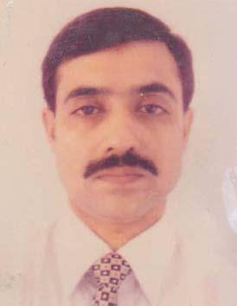 | DR. MD. MARUFUZZAMAN  F/Name:  M/Name:  BM & DC Reg. No: 25941  NID: 2697557397783  Cell: 01914389635  Address: Upazila Health Complex, Sree nagar, Munshigonj.  Blood Group: B+  TRANSFERED to BMA Dhaka City  LM-1405543
17 | Voter No  LM-4000017 | dR. CHANDAN KUMAR SAHA  F/Name: Late Jogendra Mohan Saha  M/Name: Late Rajo Bala Saha  BM & DC Reg. No: 16074  NID: 2696653240660  Cell: 01711836740  Address: Junior Consultant (Cardiology), Sreenagar, Upz Health Complex, Sreenagar, Munshiganj.  Blood Group: B+
18 | Voter No  LM-4000018  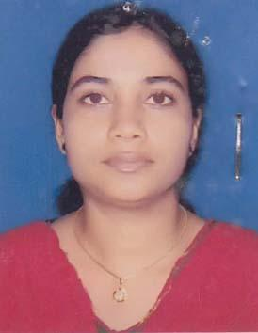 | dR. UMME KULSUM SHAMPA  F/Name: Sultan Ahmed  M/Name: Jahnara Begum  BM & DC Reg. No: 39067  NID: 5925613115546  Cell: 01712931445  Address: Vill: Sreepally, Post: Munsigonj, Dist: Munshigonj.  Blood Group: AB_ne
19 | Voter No  LM-4000019  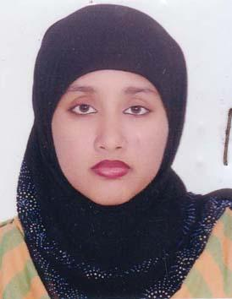 | DR. FARJZANA AKTER  F/Name: Shah Jalal  M/Name: fatema Begum  BM & DC Reg. No: 47169  NID: 5915676194525  Cell: 01937833534  Address: H # 30, R # 1, Vill: Firingi Bazar, Post: Ponchosher, Thana & Dist: Munshigonj.  Blood Group: A+
20 | Voter No  LM-4000020  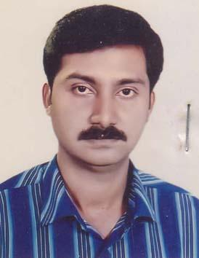 | dR. A.K.M HASSAN HAFIZUR rAHMAN  F/Name: Late Md. Bazlur Rahman  M/Name: Mrs. Hamida Rahman  BM & DC Reg. No: 39307  NID: 5925611104784  Cell: 01711666310  Address: Vill: Courtgaon, P.O & Dist: Munshigonj.  Blood Group: B+
21 | Voter No  LM-4000021  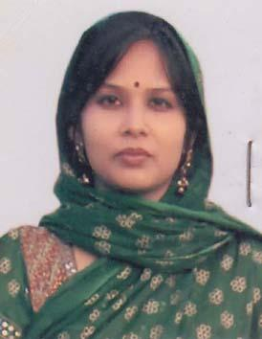 | DR. FARZANA hAQE  F/Name: Late Md. Abdul Haqe Khan  M/Name: Mrs. Khodeza Begum  BM & DC Reg. No: 43945  NID: 2693622453975  Cell: 01926604810  Address: Vill: Courtgaon, P.O & Dist: Munshiganj.  Blood Group: B+
22 | Voter No  LM-4000022  No Image | ***NIL***  F/Name:  M/Name:  BM & DC Reg. No:  NID:  Cell:  Address:  Blood Group:
23 | Voter No  LM-4000023  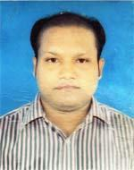 | DR. MD. KAMRUL HASAN  F/Name: D. M. Kamal Hossain  M/Name: Kamrun Nahar  BM & DC Reg. No: 56762  NID: 19875919411390068  Cell: 01718129071  Address: Vill-Uttar Paik Para, Post-Bikrumpur paik para, P.s-Tongibari, Dist-Munshigonj  Blood Group: AB+
24 | Voter No  LM-4000024  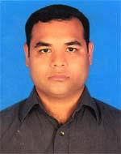 | KUMAR MRIDUL DAS  F/Name: Swapan Kumar Das  M/Name: Laxmee Rani Das  BM & DC Reg. No: 58226  NID: 5925612107815  Cell: 01715302383  Address: Nandaloy, House-731, Vill- Bagmamudali, Post-Munshiganj, P.s+Dist-Munshiganj  Blood Group: A-
25 | Voter No  LM-4000025 | DR. MONINDRA KUMAR RUDRA PAUL  F/Name: Mohendra Kumar Paul  M/Name: Gour Dasi Paul  BM & DC Reg. No: 20160  NID: 5925604157476  Cell: 01720293866  Address: New Mitali Pharmacy, Battala, Rekabi Bazar, Munshigonj  Blood Group: O+
26 | Voter No  LM-4000026  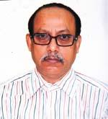 | RAGHD NATH PAUL  F/Name: Late Bharat Chandra Paul  M/Name: Late Haridasi Paul  BM & DC Reg. No: 34911  NID: 5925604158448  Cell: 01711484456  Address: Ramgopal Pur, Rekabi Bazar, Munshigonj  Blood Group: AB+
27 | Voter No  LM-4000027  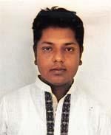 | DR. MD. ABDUL HALIM  F/Name: Md. Shahjahan Mia  M/Name: Parul Begum  BM & DC Reg. No: 58279  NID: 5912421155993  Cell: 01834413846  Address: Vill-Bayobzia, Farazikandi, Post-Bayosia, P.s-Gozaria, Dist-Munshigonj.  Blood Group: O+
28 | Voter No  LM-4000028  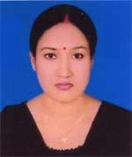 | DR. MOLLIKA SARKAR  F/Name: Monmohon Sarkar  M/Name: Rita Rani Mondal  BM & DC Reg. No: 72642  NID: 19909329502000015  Cell: 01967289914  Address: 325, Maddho Courtgaon, Munshiganj-1500  Blood Group: O+
29 | Voter No  LM-4000029  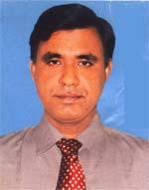 | DR. MD. SHOUKAT ALI  F/Name: Abdul Hakim  M/Name: Habiba Begum  BM & DC Reg. No: 26282  NID: 2693625665924  Cell: 01712033400  Address: Munshiganj Sadar, Munshiganj.  Blood Group: B+
30 | Voter No  LM-4000030 | DR. MD. MAHMUDUR RAHMAN  F/Name: Mustafizur Rahman  M/Name: Zebunesa Begum  BM & DC Reg. No: 60984  NID: 19890695111184865  Cell: 01717133220  Address: 383/5, West Deobhog, Munshigonj  Blood Group: A+
31 | Voter No  LM-4000031 | DR. PRONOY MANNA DAS  F/Name: Prodipto Manna Das  M/Name: Nelu Das  BM & DC Reg. No: 61723  NID: 19888198510364689  Cell: 01713920667  Address: 325, Madho Courtgaon, Munshiganj, 1500  Blood Group: O+
32 | Voter No  LM-4000032  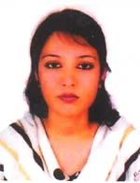 | DR. EASMIN AKTHER  F/Name: Md. Abul Kasam  M/Name: Hosne Ara  BM & DC Reg. No: 53276  NID: 262140738814  Cell: 01757800282  Address: Adariya Tola, Panchasa Munshiganj.  Blood Group: B+
33 | Voter No  LM-4000033 | DR. MD. JOBAIR ISLAM  F/Name: Md. Nazrul Islam  M/Name: Monwara Begum  BM & DC Reg. No: 53275  NID: 19862693622000065  Cell: 01757800281  Address: Munshiganj Sadar, Munhiganj.  Blood Group: O+
34 | Voter No  LM-4000034  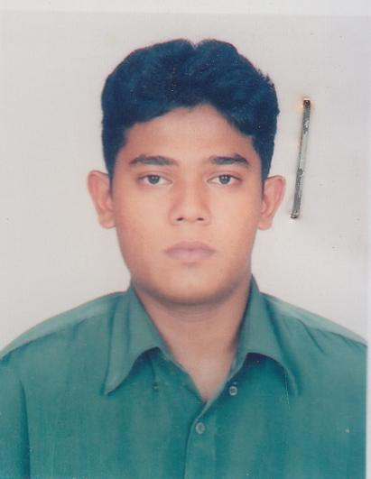 | DR. AHMED MANJURUL ISLAM  F/Name: Dr. Sultan Uddin Ahmed  M/Name: Dr. Ulfat Begum  BM & DC Reg. No: 57439  NID: 2693624684291  Cell: 01711249336  Address: Shikdar Super Market 2nd Floor, Sirajdikhan, Munshiganj  Blood Group: A+
35 | Voter No  LM-4000035  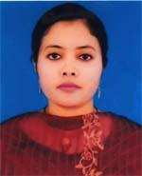 | DR. SULTANA ZAKIA FARBAY  F/Name: Md. Obaidullah  M/Name: Roushan Ara Lutfun Nahar  BM & DC Reg. No: 69049  NID: 4824903489404  Cell: 01917191449  Address: Shikdar Super Market, 2nd Floor, Sirajdikhan, Munshiganj  Blood Group: B+
36 | Voter No  LM-4000036 | DR. SANJOY KUMAR PODDAR  F/Name: Subali Chandra Poddar  M/Name: Alpana Rani Banik  BM & DC Reg. No: 46492  NID: 0695108166152  Cell: 01714091040  Address: Munshigonj Sadar, Munshiganj.  Blood Group: B+
37 | Voter No  LM-4000037  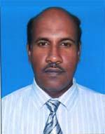 | DR. MD. DULAL HOSSAIN  F/Name: Late Taizuddin Halder  M/Name: Mrs. Saleha Begum  BM & DC Reg. No: 22876  NID: 19665917467042421  Cell: 01715536204  Address: Vill-Kakaldi, Post-Shialdi, P.s-Sirajdikhan, Dist-Munshigonj  Blood Group: B+
38 | Voter No  LM-4000038  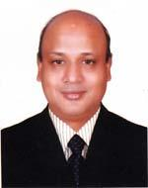 | DR. MD. BADIUZZAMAN  F/Name: Md. Aminul Haque  M/Name: Late Khodeza Khatun  BM & DC Reg. No: 24273  NID: 5925614116607  Cell: 01711260474  Address: Upazila Health Complex, Sirajdikhan, Munshigonj  Blood Group: AB+
39 | Voter No  LM-4000039  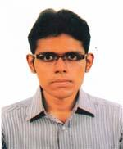 | DR. A. K. M. TAIFUL HAQUE  F/Name: Md. Ziaul Haque  M/Name: Rokeya Haque  BM & DC Reg. No: 53819  NID: 0695111189812  Cell: 01712911397  Address: Upazilla Health Complex, Sirajdikhan, Munshigonj.  Blood Group: AB+
40 | Voter No  LM-4000040  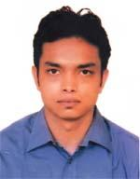 | DR. MD. IFTHEAR IRFAN  F/Name: Md. Abul Hossain  M/Name: Amena Hossain  BM & DC Reg. No: 65270  NID: 19861594116397737  Cell: 01714417449  Address: MO. USC, Chardumuria, Sadar, Munshiganj  Blood Group: A+
41 | Voter No  LM-4000041  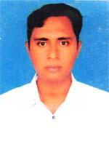 | DR. SAROWER POLASH  F/Name: Giasuddin Pathan  M/Name: Umme Salma  BM & DC Reg. No: 49413  NID: 19835912421000028  Cell: 01816107487  Address: Upazilla Health Complex, Gazaria Munshigonj.  Blood Group: O+
42 | Voter No  LM-4000042 | DR. ANIRUDDHA MONDAL  F/Name: Late Harekrisna Mondal  M/Name: Renu Mondal  BM & DC Reg. No: 44905  NID: 5917433014422  Cell: 01716405564  Address: West Rajdia, Sirajdikhan Munshigonj.  Blood Group: B+
43 | Voter No  LM-4000043 | DR. DEBASHISH GHOSH  F/Name: Late Ram Krisna Ghosh  M/Name: Protiva Rani Ghosh  BM & DC Reg. No: 55530  NID: 5917488001120  Cell: 01675620809  Address: Sontuspara, Shirajdikhan Munshigonj.  Blood Group: B+
44 | Voter No  LM-4000044 | DR. PIJUSH PAUL  F/Name: Badal Chandra Paul  M/Name: Laxmi Rani Paul  BM & DC Reg. No: 46027  NID: 5917440053158  Cell: 01717374235  Address: Champakdi, Ichhapara. Munshigonj.  Blood Group: A+
45 | Voter No  LM-4000045  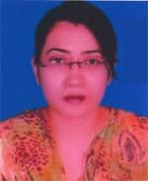 | DR. NILIMA BARMAN  F/Name: Subodh Chandra Barman  M/Name: Asha Barman  BM & DC Reg. No: 51333  NID: 19846125209172223  Cell: 01716195598  Address: Santoshpara, Sirajdikhan, Munshigonj  Blood Group: A+
46 | Voter No  LM-4000046  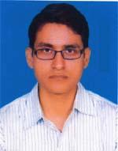 | DR. DEBABRATA GHOSH  F/Name: Santi Ranjan Ghosh  M/Name: Chhaya Ghosh  BM & DC Reg. No: 39627  NID: 1978698876359979  Cell: 01716358950  Address: Santoshpara, Sirajdikhan, Munshigonj  Blood Group: O+
47 | Voter No  LM-4000047  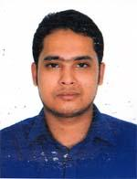 | DR. MD. ASADUZZAMAN SAGOR  F/Name: Md. Nurul Haque  M/Name: Asma Akter  BM & DC Reg. No: 70710  NID: 5915685227981  Cell: 01710008108  Address: Vill: Khanka, Post: Rampal, P.S: Munshiganj Sadar, dist: Munshiganj  Blood Group: A+

